2804 SEAL OF REGISTRANT

2804.1 The seal of a Registered Land Surveyor shall be of the following design:
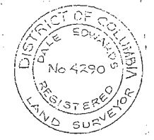
2804.2 The seal shall not be larger than one and three-quarters inches (1³/₄in.) or less than one and five-eighths inches (1⁵/₈ in.).

2804.3 The seal shall be impressed on all plats and wall reports or a facsimile imprint of same shall be stamped on all plats and wall examination reports submitted to the Office of the Surveyor for recording or filing.

2804.4 It shall be a violation of this chapter for any person to apply or affix the registration seal on any plat or on any document that is not submitted for recording or filing in the Office of the Surveyor pursuant to this chapter.

2804.5 It shall be a violation of this chapter for any person to use the seal during the period that registration of the holder is expired, suspended or revoked.

2804.6 It shall be a violation of this chapter for any person to use the seal of any design not in accordance with this chapter.

SOURCE: Final Rulemaking published at 38 DCR 2131, 2134 (April 12, 1991).

